# Sometimes Y Rapid Prototype Screens

Alright, I have developed a rapid prototype for the application, this certainly doesn’t represent what the final product will look like, but it does demonstrate some of the features that will be seen. The actual game will look much better than this. These screens are based on the first puzzle described in the specification document. Note that this prototype supports the game logic, but user input has not been implemented so all inputs must be hard coded into the programming language. For this reason only screenshots of the various game states can be provided.

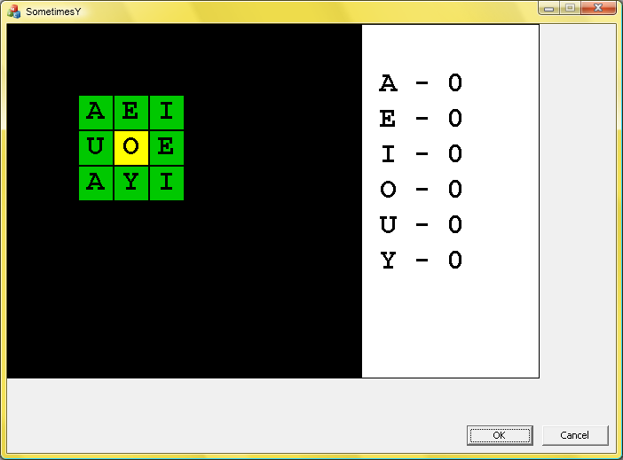

This screen shows a completed game. All letters that have been placed are highlighted green, and all fixed letters (the letters that were placed at the start of the game) are highlighted bright yellow.

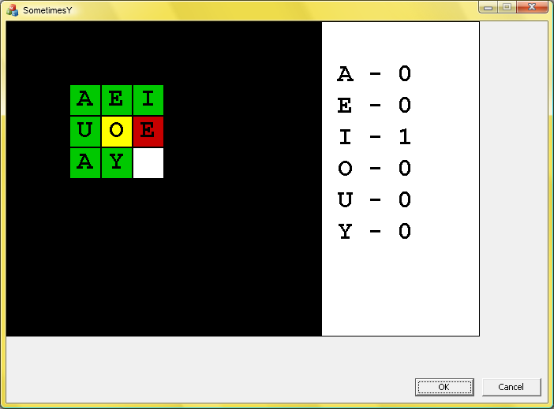

This screen shows what an invalid letter placement looks like. In this case E has to have at least three letters on its sides, but it only has two.

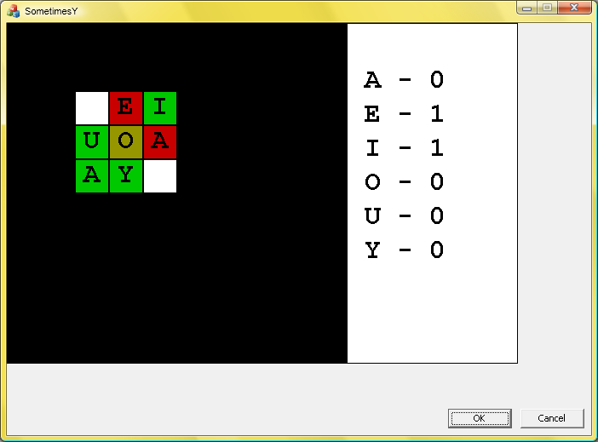

This screen shows several invalid placements, and because of the placements the fixed letter O is invalid, and therefore is highlighted with a dull yellow.